Qestion1: (a)

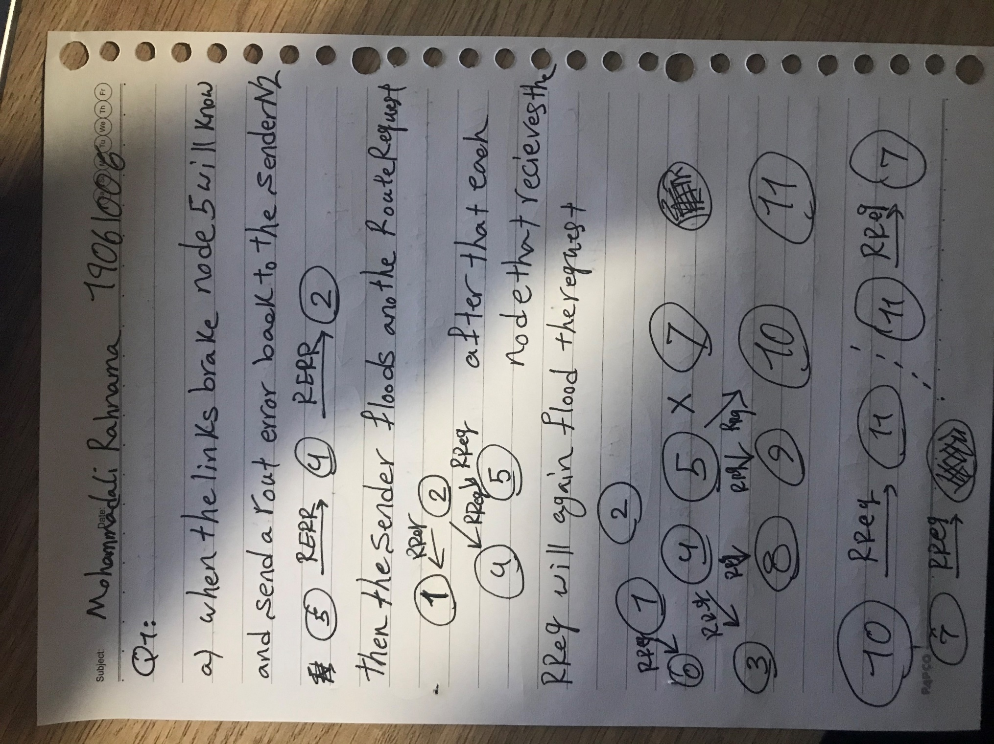

Qestion1: (a cont. + b)

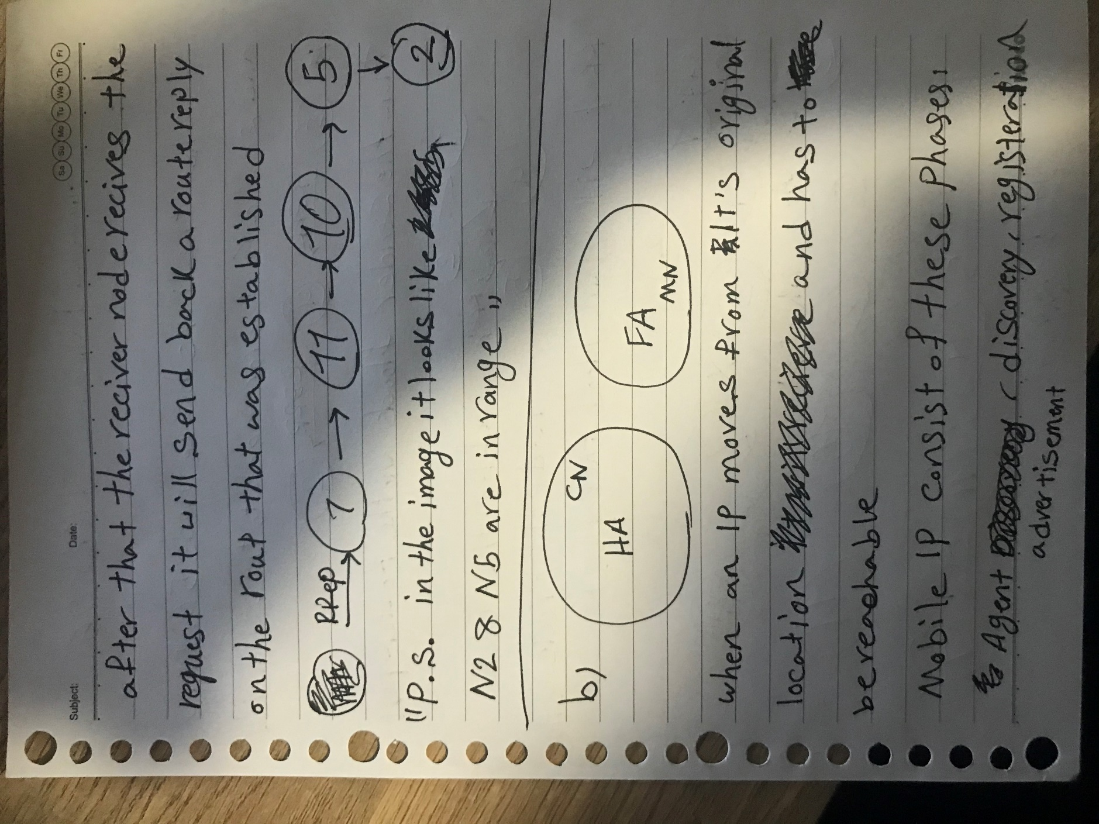

Qestion1: (b cont.)

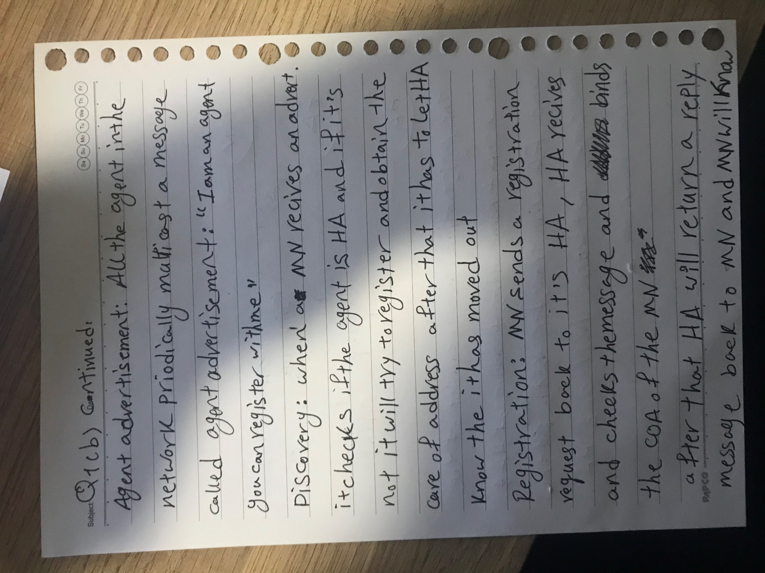

Qestion1: (b cont.)

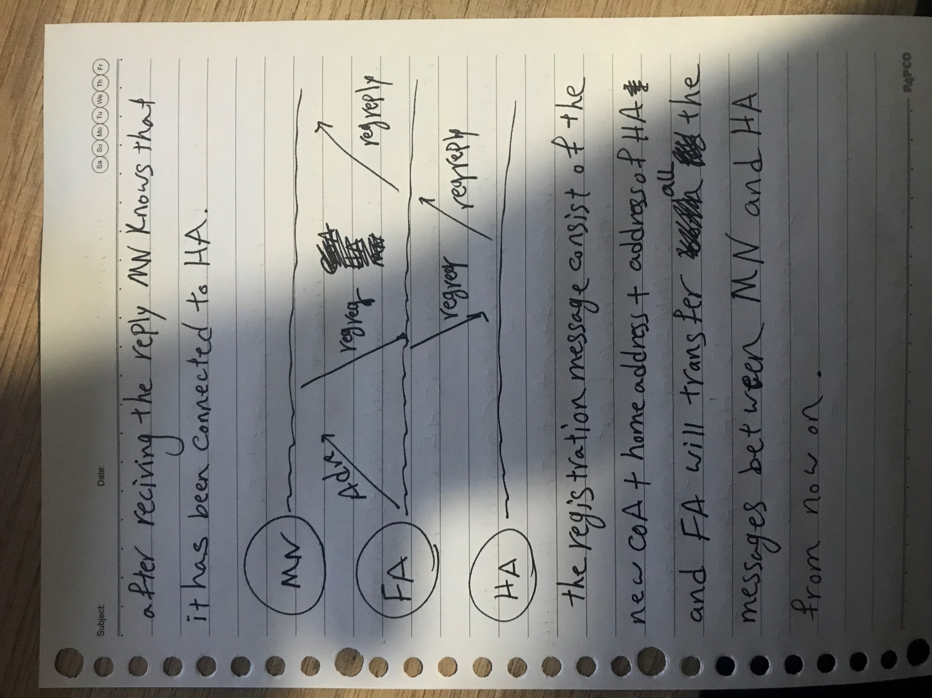

Qestion1: (c + d)

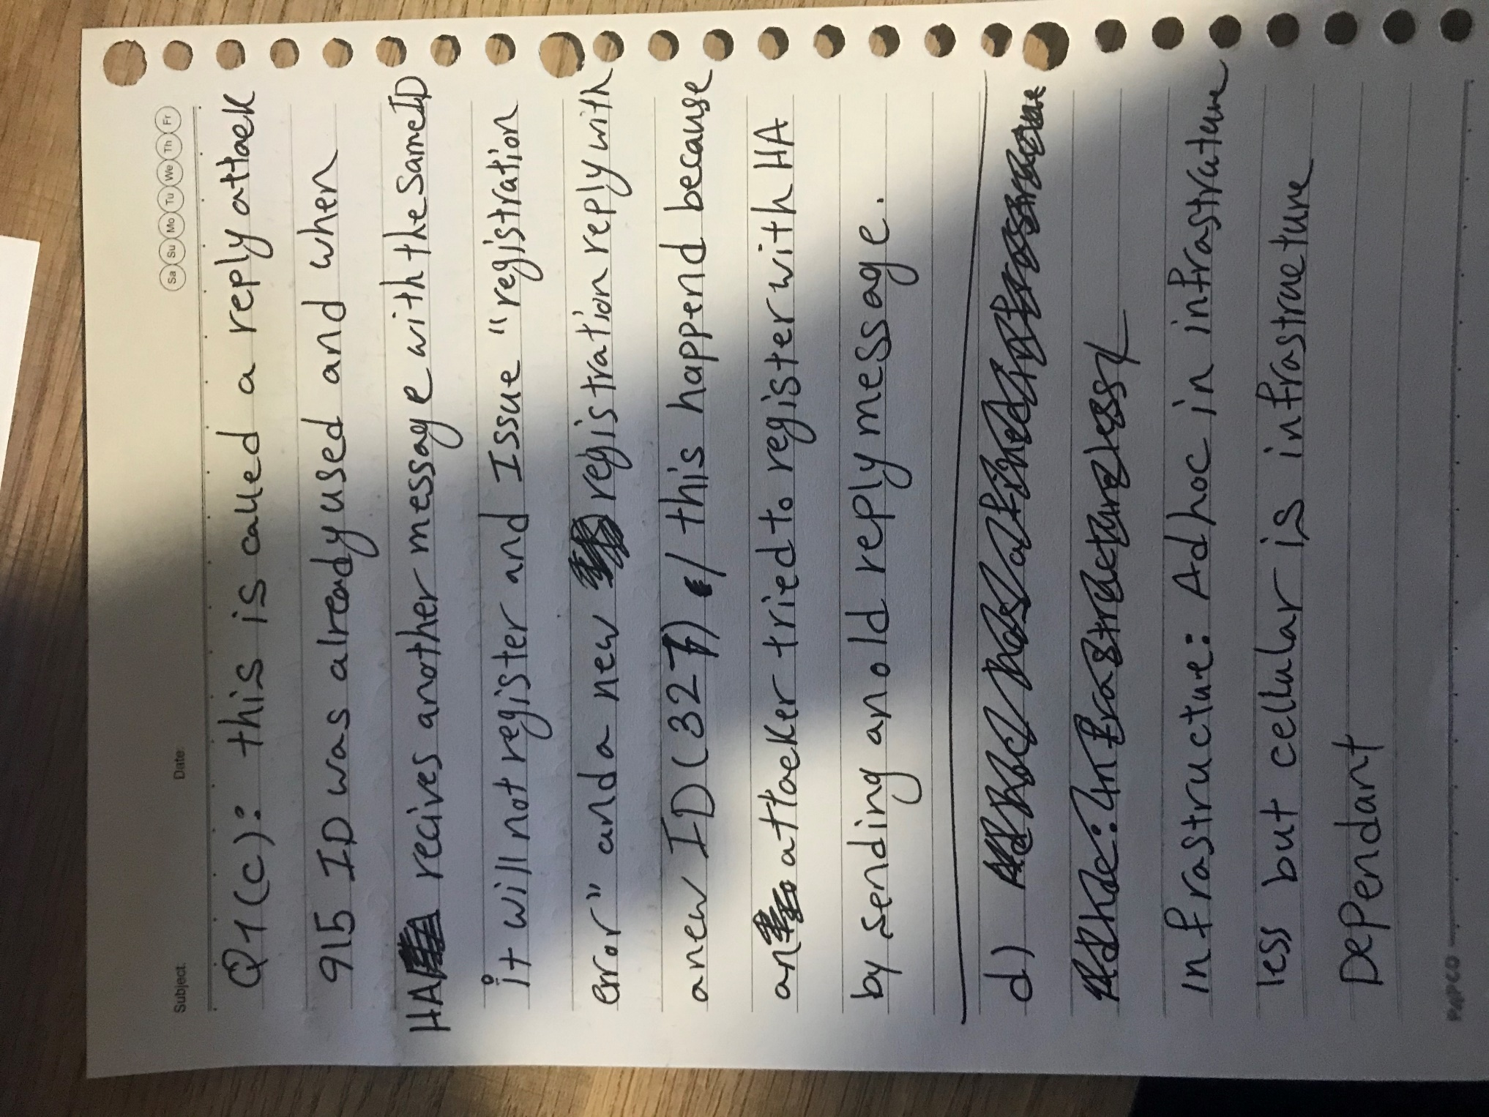

Qestion1: (d cont.)

